***Networks (pdf – Information Technology)***

***Ex. 6***

|  |  |
| --- | --- |
| ***Advantages*** | ***Disadvantages*** |
| ***You don't need cabling.You can work anywhere.On a sunny day u could work outside.*** | ***Wireless networks are much slower.Wireless NICs are more expensive than the wired versions.*** |

***Ex. 4***

***Ex.4***

1. ***enabling***
2. ***used***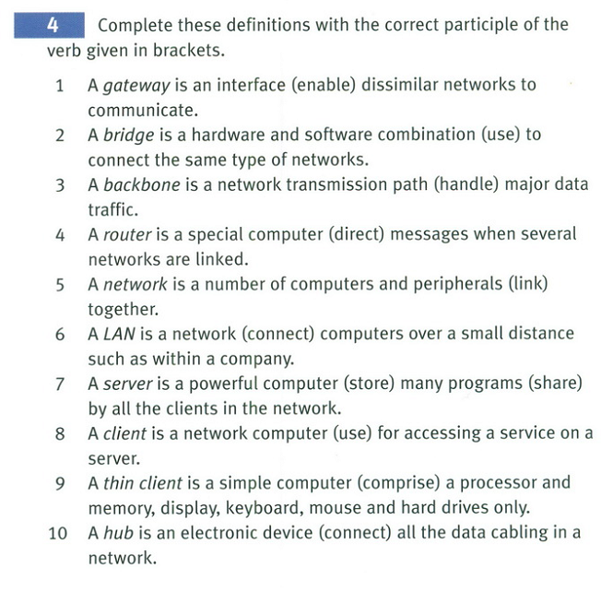
3. ***handling***
4. ***directing***
5. ***linked***
6. ***connecting***
7. ***storing, shared***
8. ***used***
9. ***comprising***
10. ***connecting***

***Ex.5***

|  |  |
| --- | --- |
| ***1*** | ***The technology needed to set up a home network is here today.*** |
| ***2*** | ***You only need one network printer connected to the server.*** |
| ***3*** | ***Her has a network allowing basic file-sharing and multi-player gaming.*** |
| ***4*** | ***There is a line receiver delivering home entertainment audio to speakers in the living room.*** |
| ***5*** | ***Eve has designed a site dedicated to dance.*** |
| ***6*** | ***She has built in links connecting her site to other dance sites.*** |
| ***7*** | ***She designed the site called Dreamweaver which uses a website creation program.*** |
| ***8*** | ***At the center of the home of tomorrow is a network accessed through a control pad.*** |
| ***9*** | ***The network can simulate the owners presence making sure vital tasks carried out in her absence.*** |
| ***10*** | ***The house has an electronic door-keeper programed to recognise you and giving access to family only.*** |

***Ex. 8 (3,4)***

***8.3***

|  |  |
| --- | --- |
| ***A*** | ***2*** |
| ***B*** | ***6*** |
| ***C*** | ***4*** |
| ***D*** | ***3*** |
| ***E*** | ***1*** |

***8.4***

|  |  |
| --- | --- |
| ***A*** | ***Transport layer,segments*** |
| ***B*** | ***Expended,decrypted*** |
| ***C*** | ***Bits*** |
| ***D*** | ***Layer*** |
| ***E*** | ***readable,to the correct application*** |
| ***F*** | ***Packets,security*** |
| ***G*** | ***Data link,log,checksum*** |
| ***H*** | ***Held,session,complete.*** |

***Reading***

***Task A***

|  |  |
| --- | --- |
| ***1*** | ***a*** |
| ***2*** | ***To confirm that the data has arrived undamaged*** |
| ***3*** | ***Until it receives the confirmation from the next point of the route*** |
| ***4*** | ***Confirmation and verification of the checksum of each packet*** |
| ***5*** | ***a-Presentation layer***  ***b-Transport layer***  ***c-Physical layer***  ***d-Data link layer***  ***e- application layer***  ***f-session layer***  ***g-network layer***  ***h-transport layer***  ***i-data link layer*** |

***Task B***

***1.***

|  |  |
| --- | --- |
| ***1*** | ***iii*** |
| ***2*** | ***I*** |
| ***3*** | ***iv*** |
| ***4*** | ***ii*** |

***2.***

|  |  |
| --- | --- |
| ***A*** | ***True*** |
| ***B*** | ***False*** |
| ***C*** | ***True*** |
| ***D*** | ***True*** |
| ***E*** | ***False*** |
| ***F*** | ***True*** |
| ***G*** | ***True*** |

***Revision***

***who, what, which, where, why, when, whose, whenever, whoever, wherever, whatever / that***

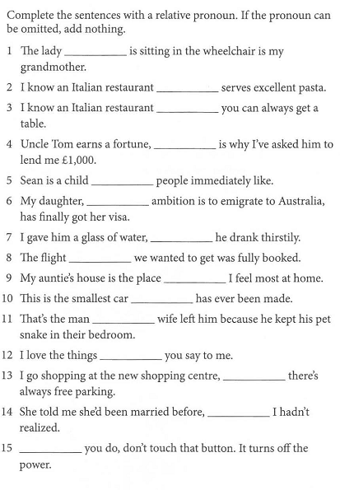

|  |  |
| --- | --- |
| ***1*** | ***who*** |
| ***2*** | ***which*** |
| ***3*** | ***where*** |
| ***4*** | ***that*** |
| ***5*** | ***that*** |
| ***6*** | ***whose*** |
| ***7*** | ***which*** |
| ***8*** | ***-*** |
| ***9*** | ***where*** |
| ***10*** | ***that*** |
| ***11*** | ***whose*** |
| ***12*** | ***-*** |
| ***13*** | ***where*** |
| ***14*** | ***what*** |
| ***15*** | ***whatever*** |

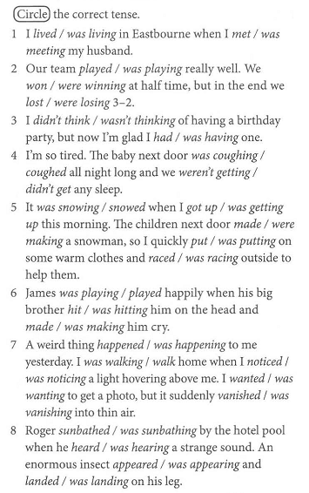

|  |  |
| --- | --- |
| ***1*** | ***was living, met.*** |
| ***2*** | ***was playing. won, lost.*** |
| ***3*** | ***didn’t think, had.*** |
| ***4*** | ***was coughing, didn't get.*** |
| ***5*** | ***It was snowing, got up.were making,put on,raced*** |
| ***6*** | ***was playing,hit,made.*** |
| ***7*** | ***happened, was walking , noticed , wanted, vanished.*** |
| ***8*** | ***was sunbathing,heard. appeared ,landed.*** |

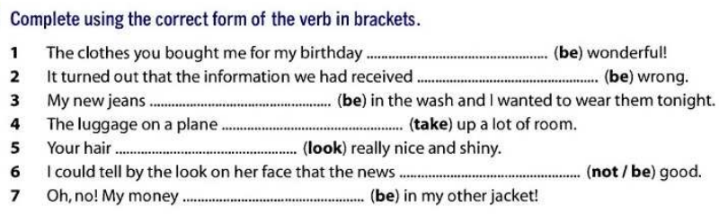

|  |  |
| --- | --- |
| ***1*** | ***were*** |
| ***2*** | ***was*** |
| ***3*** | ***were*** |
| ***4*** | ***takes*** |
| ***5*** | ***looks*** |
| ***6*** | ***is not*** |
| ***7*** | ***is*** |

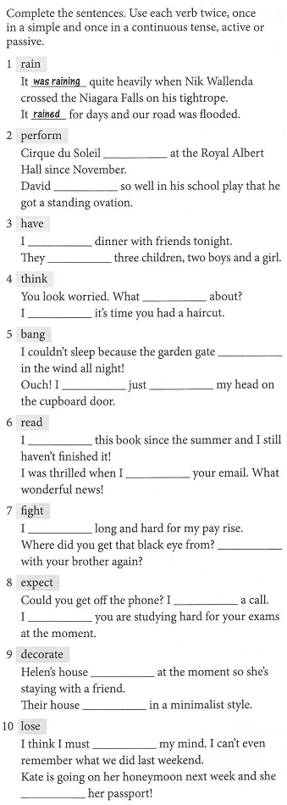

|  |  |
| --- | --- |
| ***1*** | ***-*** |
| ***2*** | ***has been performing. performed.*** |
| ***3*** | ***am having. have.*** |
| ***4*** | ***are u thinking. think.*** |
| ***5*** | ***was banging.have just banged.*** |
| ***6*** | ***have been reading.read.*** |
| ***7*** | ***have fought.Have u fought.*** |
| ***8*** | ***am expecting.expect.*** |
| ***9*** | ***is being decorated.is decorated.*** |
| ***10*** | ***have lost.has lost.*** |

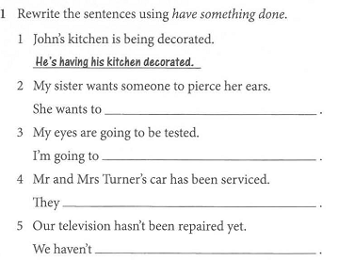

|  |  |
| --- | --- |
| ***1*** | ***-*** |
| ***2*** | ***She wants to have her ears pierced.*** |
| ***3*** | ***I'm going to have my eyes tasted.*** |
| ***4*** | ***They have had their car serviced.*** |
| ***5*** | ***We haven’t had our television repaired.*** |

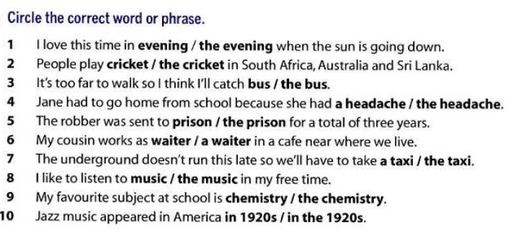

|  |  |
| --- | --- |
| ***1*** | ***the evening.*** |
| ***2*** | ***cricket.*** |
| ***3*** | ***the bus.*** |
| ***4*** | ***a headache.*** |
| ***5*** | ***prison.*** |
| ***6*** | ***a waiter.*** |
| ***7*** | ***a taxi.*** |
| ***8*** | ***music.*** |
| ***9*** | ***chemistry.*** |
| ***10*** | ***in the 1920s.*** |

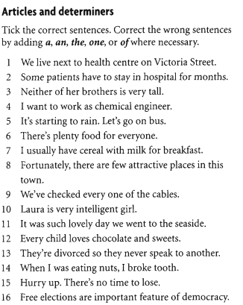

|  |  |
| --- | --- |
| ***1*** | ***the Health centre*** |
| ***2*** | ***+*** |
| ***3*** | ***+*** |
| ***4*** | ***a chemical engineer*** |
| ***5*** | ***On a bus*** |
| ***6*** | ***Plenty of food*** |
| ***7*** | ***+*** |
| ***8*** | ***A few*** |
| ***9*** | ***+*** |
| ***10*** | ***A very*** |
| ***11*** | ***A lovely day*** |
| ***12*** | ***+*** |
| ***13*** | ***To one another*** |
| ***14*** | ***A tooth*** |
| ***15*** | ***+*** |
| ***16*** | ***Are an important*** |

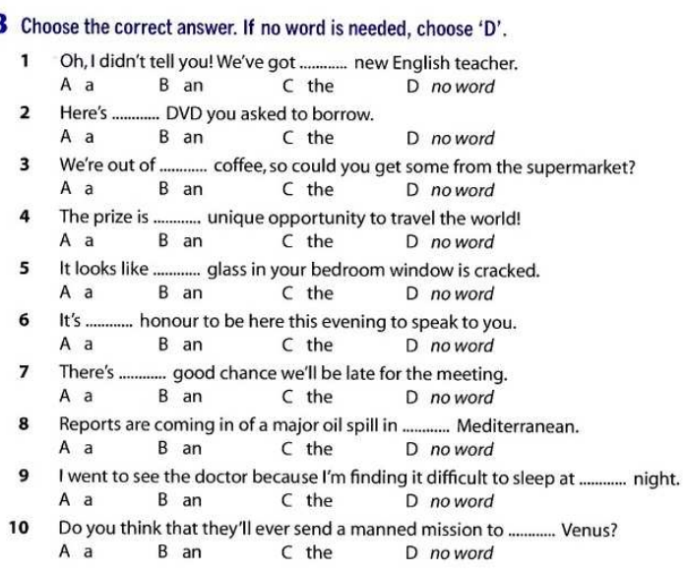

|  |  |
| --- | --- |
| ***1*** | ***A*** |
| ***2*** | ***C*** |
| ***3*** | ***D*** |
| ***4*** | ***A*** |
| ***5*** | ***C*** |
| ***6*** | ***B*** |
| ***7*** | ***A*** |
| ***8*** | ***C*** |
| ***9*** | ***D*** |
| ***10*** | ***C*** |